**Deliverable:**

**3 Key Tasks:**

1. Primary Stakeholder - Schedule a food delivery - dates + time
   1. Relevance: With our primary stakeholders including those who are food insecure and lack access to transportation, a way for these users to schedule food deliveries within our system is extremely important, so we prioritized it first.
2. Primary Stakeholder - Organizers view sign ups and organize delivery at requested times and locations
   1. Relevance: As ACFB organizers are also primary stakeholders that interact directly with the system, they need to be able to view data inputted by food insecure people to organize and coordinate volunteers to deliver food.
3. Secondary Stakeholder- Volunteers sign up to deliver food
   1. Relevance: Volunteers are also important because they are the ones who will be delivering to the food insecure. We need to make sure we have sufficient drivers, so we chose to include this task.

**1 Interface that best fits these tasks:**

* Website
* Rationale(3-4 Sentences):

From our P2 report, we were able to find that our website rated the highest amongst our evaluation criteria. In addition, amongst the feedback received from the poster session, we also received feedback that the website was the optimal design alternative. We also wanted to make sure that the interface that we chose would be an interface that users would have access to. From our survey in P1, we found that most users had access to a laptop device and the internet. In the case that the users don’t, there is also the opportunity for users to go to public spaces like libraries to use laptops and access our web application. With all these considerations in mind, we decided that a website is best fit for the task of scheduling food delivery because it provides a richer interface for more information to be presented and more feedback to be given. A website can have multiple pages to include all of the functionality that we aim to create for our users. More information on what these pages would look like can be seen below in our Exercise 2.

**Exercise 1:**

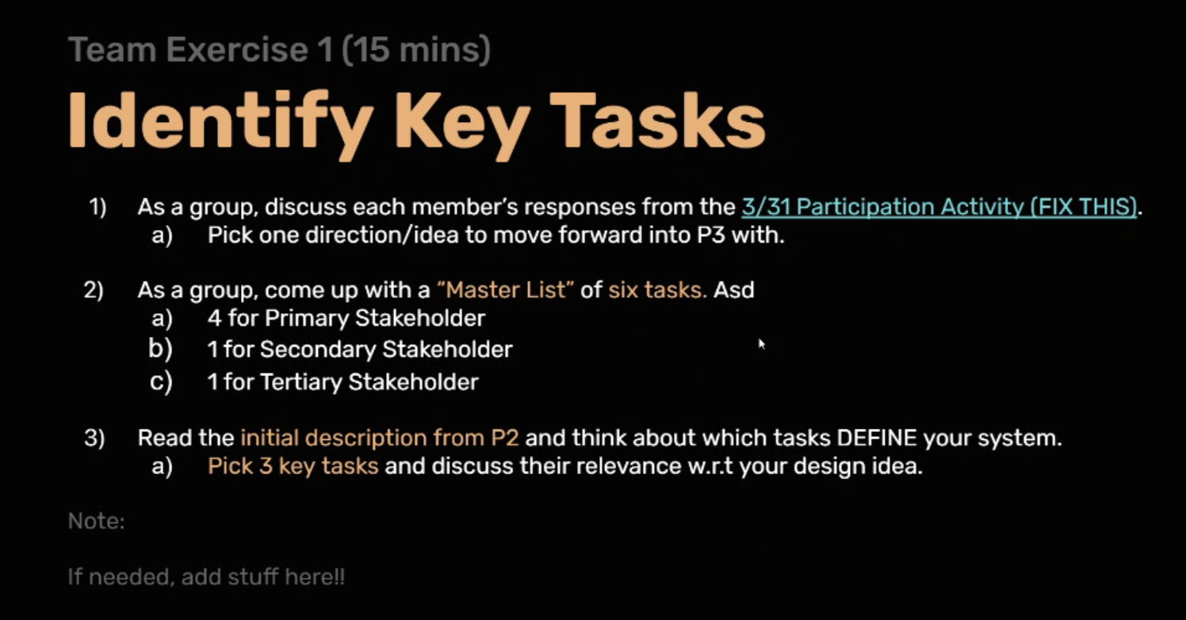

Primary: Organizers, and Food Insecure

Secondary: ACFB Volunteers

Tertiary: people donating food to ACFB

Master List of Six Tasks:

1. Primary - Schedule a food delivery - dates + time
2. Primary- Input personal information
3. Primary - Input food preferences/dietary restrictions
4. Primary- Organizers view sign ups and organize delivery at requested times
5. Secondary- Volunteers sign up to deliver food
6. Tertiary- Donors see user’s food preferences to adjust donations

Three Key Tasks:

1. Primary - Schedule a food delivery - dates + time
2. Primary- Organizers view sign ups and organize delivery at requested times
3. Secondary- Volunteers sign up to deliver food

Philena:

1) Design Alternative 1: Website

2) 7 Tasks

| Fill Out Personal Information | Primary |
| --- | --- |
| Pick Food preferences | Primary |
| Select Time/Date for Delivery | Primary |
| Check if user's address is in deliverable range | Primary |
| Find other ACFB locations | Primary |
| Find Mobile Pantry locations | Primary |
| Tell parents food preferences | Secondary- Kids of Parents |
| View the most common food preferences | Tertiary- ACFB Donors |

6) Task: Select Time/Date for Delivery

Criteria: Utility is a 5/5

This is subjective.

Tim:

1. Website

2+3. Primary (food insecure people): input personal information, provide availability, input food option preferences, set up delivery

Secondary (ACFB volunteers): Organize food for delivery, see users' delivery needs, deliver food to food insecure people

Tertiary (ACFB donors): See where their donations are actively helping ACFB processes

6. #1 task is setting up food delivery - evaluation with convenience - it is convenient because the user just has to fill out information and have food delivered to them, as long as they have access to the internet.

7. Subjective data - convenience varies between each individual user, can't be measured quantitatively

Emma:

1) I think the text message service has been picked based on P2, although it is very very close to the website in our rankings and in feedback from the poster session

2) a. See if a delivery service is available in their area

b. Request a food delivery

c. Input any dietary restrictions to be accounted for in delivery

d. Schedule a delivery date/time

e. Cancel delivery

f. Volunteers receive data in order to organize delivery

g. Volunteers deliver food

3) a. primary

b. primary

c. primary, secondary

d. primary

e. primary

f. primary

g. primary, tertiary

4) Input number of people in household (children of users)

5) People who donate food regularly donate specific things based on what dietary restrictions users typically have and what types of food are easier to deliver

6) Accessibility - This task would be accessible to anyone with access to text messaging, which based on data collected for P1 is a vast majority of proxy users. a) this is objective data, because we have a direct observation that most potential users would find this system accessible and be able to complete this task

Erin:

1) web application

2) 7 tasks:

* sign up for delivery service online - primary
* cook with the food that was delivered - primary
* eat food that was delivered - secondary
* donate food for the delivery service program for ACFB - tertiary
* schedule delivery day and time - primary
* make updates to website when there are changes to the delivery system - primary
* deliver food to person who requested delivery - primary

6) task: sign up for delivery service online

usability criteria: efficiency

signing up for the delivery service through a web application would be quick and effective, having a high efficiency. Rather than having to write out everything on a piece of paper and submitting it to ACFB, having a website to submit sign up information makes the process more efficient for both the user and ACFB staff handling the delivery service.

6a) subjective data

Hannah:

1) Website Design Alternative

2)

1. Search if their location is deliverable, primary
2. Get access to ACFB and its partners' services, primary
3. Order a delivery service, primary
4. Volunteer for ACFB delivery service, secondary
5. Schedule delivery, primary
6. Receive delivered food, primary
7. Deliver food that has been ordered, secondary

6) task: (c),efficiency

6a) subjective

**Exercise 2:**

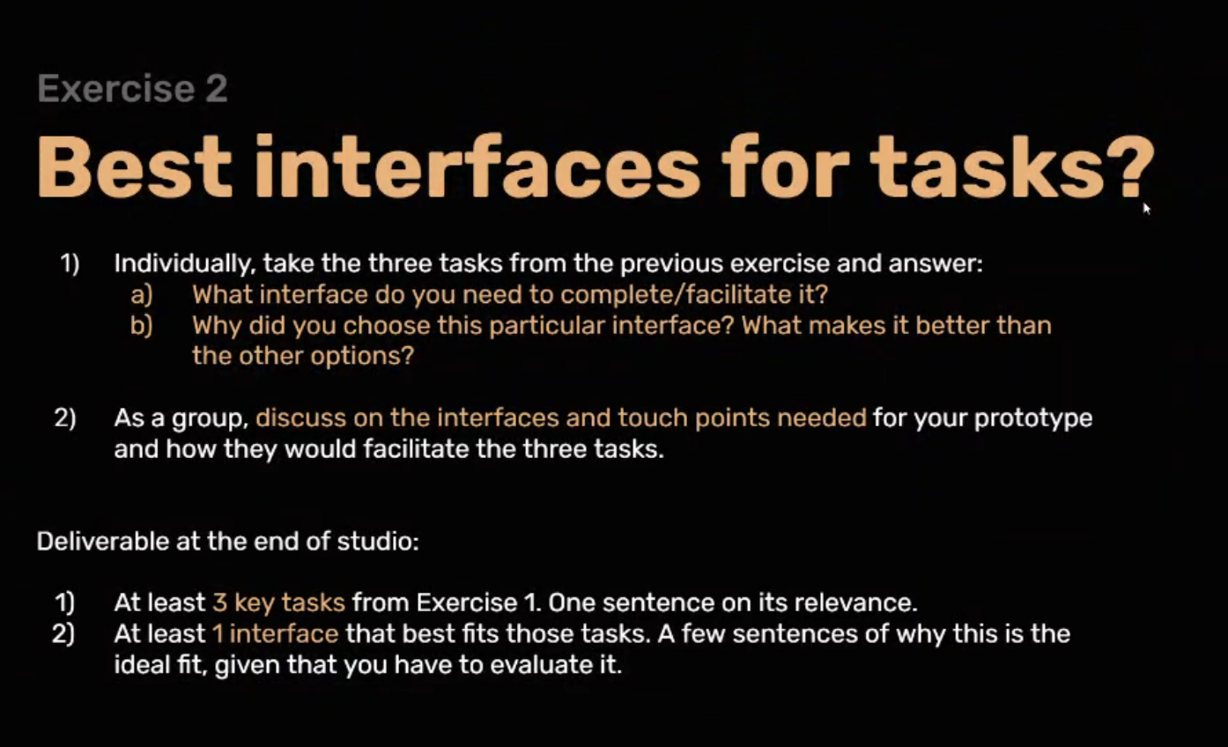

Philena:

Three Key Tasks:

1. Primary - Schedule a food delivery - dates + time
   1. Interface: Page that users can input availability(drop downs with calendars and times), add food preferences(dropdown) but also an “Other:” input box, & put their address in
2. Primary- Organizers view sign ups and organize delivery at requested times
   1. Interface: Page that allows organizers to input their availability, so we can organize deliveries for them to make, Another page that shows the assigned deliveries for that day
3. Secondary- Volunteers sign up to deliver food
   1. Interface: Page with a “Volunteer to Deliver Food” button, this leads to another page in which volunteers are shown what foods they should donate, how to donate, and where to donate

Hannah:

Three Key Tasks:

1. Primary - Schedule a food delivery - dates + time
   1. Interface: Alternate page where users can fill out their personal information, food options, list any dietary restrictions/allergies, and in the end select dates and time to have their food delivered
   2. The interface is similar to ACFB’s volunteer sign up interface, so design aspects will be consistent across different pages of ACFB, and the design is simple for users to quickly understand what to do and how to fill it out.
2. Primary- Organizers view sign ups and organize delivery at requested times
   1. Interface: Alternate page that allows only organizers to view the information submitted by users who have scheduled delivery. List will be similar to an excel sheet, and they will be able to export the information into excel sheet
   2. Easy to search for users, categorize users into specific selections they have made by making it similar to excel and be able to export as excel sheet
3. Secondary- Volunteers sign up to deliver food
   1. Interface: Additional tab under the volunteer page under ACFB’s website to include an option where volunteers can sign up to deliver food.
   2. The page is already set up for different volunteer options, so it will be easy for volunteer users to access the new option/button.

Tim:

Three Key Tasks:

1. Primary - Schedule a food delivery - dates + time
   1. Interface: web page where users can input their information and date/time for delivery
   2. This interface is a good choice because more information can be presented on a web page, as compared to a mobile screen/text. It would be easier for the user to fill out their information.
2. Primary- Organizers view sign ups and organize delivery at requested times
   1. Interface: web page with food delivery requests from food insecure people
   2. Richer information formatting, easier to navigate and organize data
3. Secondary- Volunteers sign up to deliver food
   1. Interface: web page with sign up slots / information about deliveries (time, address, etc.)
   2. Volunteers can access delivery times and requests - easier to navigate on web page, better feedback on selected time slots + locations

Emma

Three Key Tasks:

1. Primary - In-need users scheduling delivery date/time
   1. Interface: page with sections that allow users to input date/time for delivery, or pick a date/time for delivery from a list of options
   2. Allows for easy sign ups, would be connected to already existing website, would be easy to use for those already familiar with website
2. Primary - Organizers view sign-ups, preferences, addresses
   1. Interface: page with list of sign-ups, preferences, and addresses, maybe with some organization by area and time to make delivery routes?
   2. Allows for all information in one place in a somewhat organized way, makes organizing easier
3. Secondary - volunteers sign up to deliver food
   1. Interface: page with list of routes/areas that need delivery drivers with option to sign up
   2. Allows for all information in one place, would show where they would be driving/how far away it would be

Erin

Three Key Tasks:

1. Primary - Schedule a food delivery - dates + time
   1. Website page where a user can input information for their food delivery
   2. Easier to record information when the user schedules the food delivery. Also, doesn’t require paper or people manually having to record the delivery time.
2. Primary- Organizers view sign ups and organize delivery at requested times
   1. Website page where organizers can view the delivery sign ups and check what sign ups have been delivered/facilitate the delivery
   2. Easy to implement a real time update of data when users sign up. It makes it faster to view sign ups immediately and check which have been delivered successfully
3. Secondary- Volunteers sign up to deliver food
   1. Website page where volunteers can input information to sign up to deliver food
   2. Easy to input information to sign up and obtain recorded information online